Introduction to Astronomy and Astrophysics Spring 2010
Homework #7

1. Briefly describe the evolution of the following stars from the zero-age main sequence until their demise:
- a 10 solar mass star
- a 0.1 solar mass star

2. The following table gives on model for the future evolution of the Sun. For each future time, find the effective temperature of the Sun.
Time (Gy) | Luminosity (L) | Radius (R)
5.5 | 1.08 | 1.04
6.6 | 1.19 | 1.08
7.7 | 1.32 | 1.14
8.8 | 1.50 | 1.22
9.8 | 1.76 | 1.36

3. The spiral galaxy NGC 925 is one target of the HST Key Project on the Extragalactic Distance Scale. The following table shows V-band apparent magnitudes of selected Cepheids. Find the distance modulus to each Cepheid. Find the distance to NGC 925 from the average of the measurements of the distance modulus, if Av=0.42 (This is the magnitude of the extinction between us and the Cepheid variables. If we had seen an apparent magnitude 18 without the dust, for example, the fact that the dust is there means we will measure an apparent magnitude of 18.42.). (Hint: Doing this in Excel will shorten the time to completion. The distance modulus for Cepheid number 5 is 29.31.)

Cepheid number | Period (days) | V
5 | 48.5 | 23.68
8 | 37.3 | 24.67
15 | 30.1 | 24.85
36 | 20.2 | 25.35
77 | 10.8 | 25.90

*4. All questions refer to attached H-R diagram.
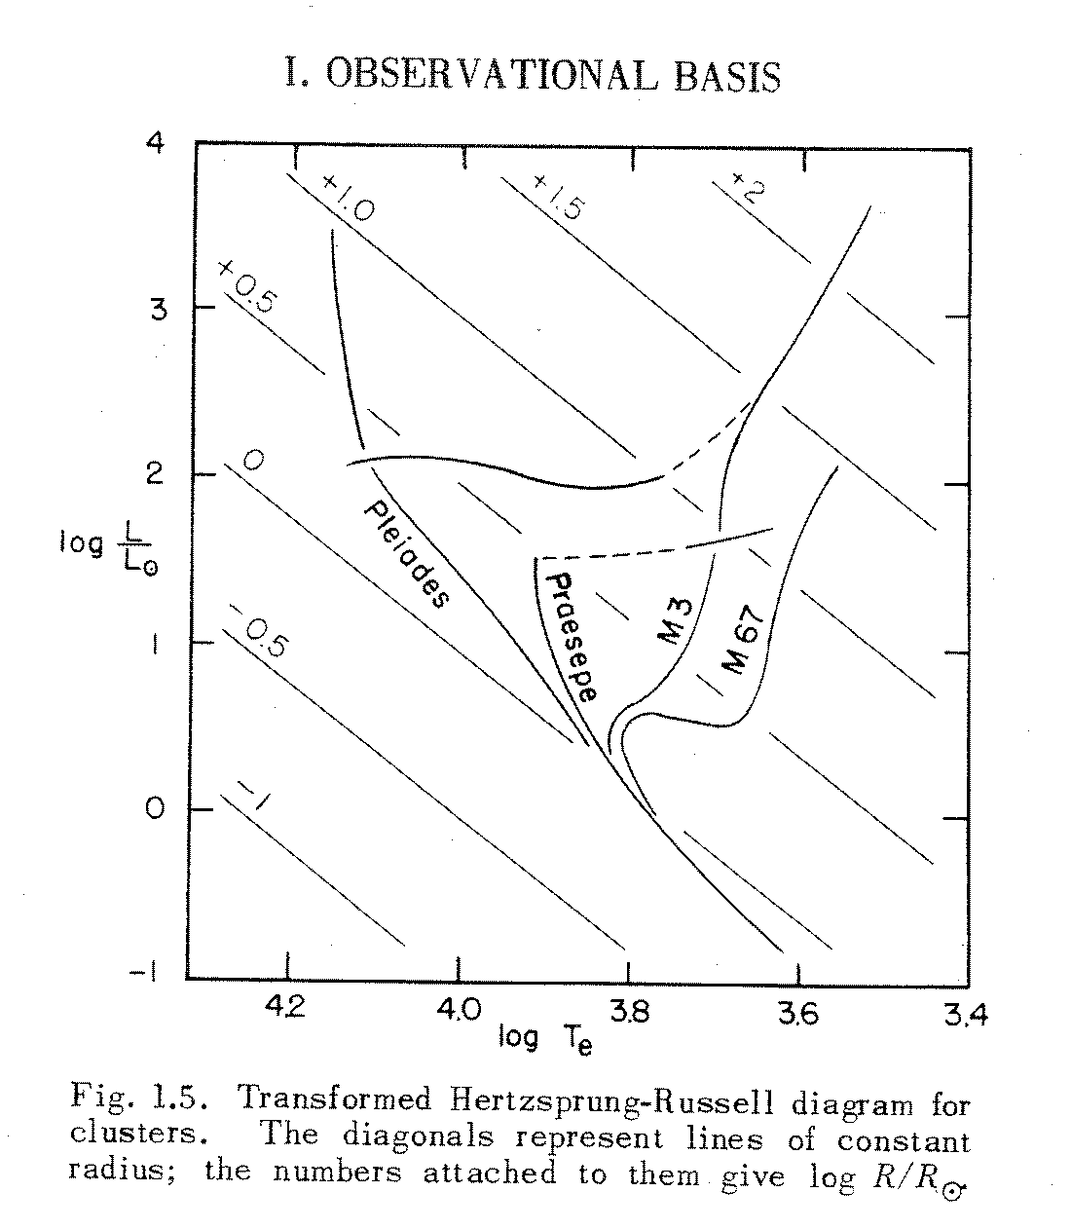
(a) Mark the position of the Sun on this H-R diagram.
(b) Mark the positions of B0 V, A0 V, F0 V, and G0 V stars. The absolute magnitude of the Sun is M_{V} = 4.82. Use Table A4-3 in the text to find the temperature and absolute
magnitudes of these spectral types.
(c) Mark the positions of stars of masses (0.6, 0.8, 2, 3, 5, and 10) M. The luminosity of main sequence stars more massive than 0.4 solar masses is proportional to M⁴, and the temperature is proportional to the square root of the mass.
(d) How long do the most luminous stars in the Pleides live? What does that tell you about the age of this cluster?
(e) How old is M67? (You can estimate this by finding the lifetimes of the most massive main sequence stars in the cluster.)

